CHILD AND FAMILY HEALTH SERVICE (CaFHS)
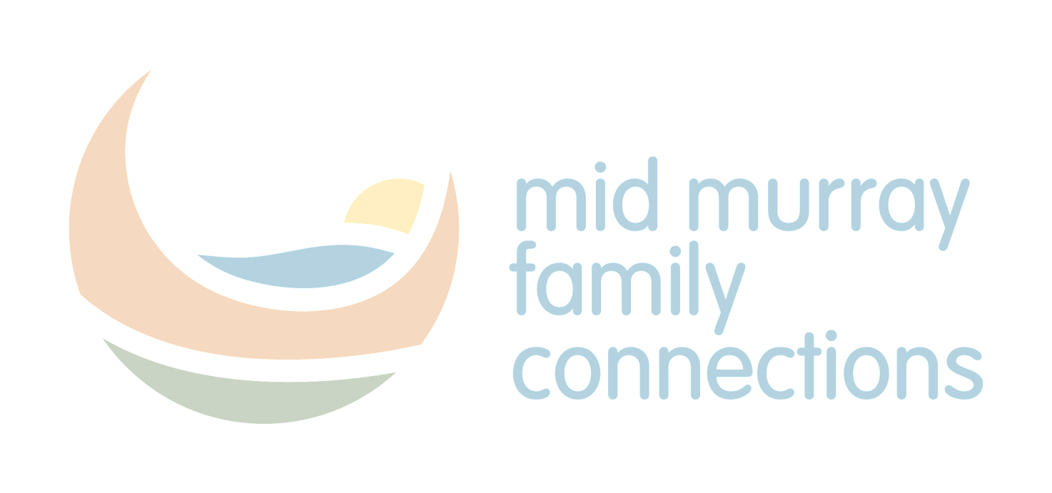
CaFHS Child Health Nurses provide free health checks and developmental assessments for children between birth and 5 years:
- 1 - 4 weeks (at the first home visit)
- 6 weeks (recommended assessment by the GP)
- 6 months
- 18 months
- 3 years
- Pre-school checks are completed at kindergarten, pre-school or the CaFHS clinic in the year before school.
CaFHS is a community based State-wide service that provides parenting support, assistance with feeding and settling babies and children, free health checks, developmental assessments and age appropriate guidance for babies and preschool children.

Services available via Clinics, Home visiting, Parenting groups and Specialised Residential support.

Clinics* at Murray Bridge, Mannum, and Nuriootpa & Waikerie. Phone 1300 733 606 for all appointments.

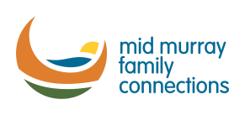
* Immunisation can be completed at some clinics
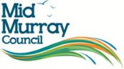 Printed May 2018

